**DBMS LAB 5**

**PROGRAM 5: AIRLINE FLIGHT DATABASE**

Consider the following database that keeps track of airline flight information:  
  
  
FLIGHTS(flno: integer, from: string, to: string, distance: integer, departs: time, arrives: time, price: integer)  
AIRCRAFT(aid: integer, aname: string, cruisingrange: integer)  
CERTIFIED(eid: integer, aid:integer)  
EMPLOYEES(eid: integer, ename: string, salary: integer)

**CREATE TABLE FLIGHTS**

**(**

**FLNO INTEGER PRIMARY KEY,**

**FFROM VARCHAR(15) NOT NULL,**

**TTO VARCHAR(15) NOT NULL,**

**DISTANCE INTEGER,**

**DEPARTS TIMESTAMP,**

**ARRIVES TIMESTAMP,**

**PRICE REAL**

**);**

**CREATE TABLE AIRCRAFT**

**(**

**AID INTEGER PRIMARY KEY,**

**ANAME VARCHAR(10),**

**CRUISINGRANGE INTEGER**

**);**

**CREATE TABLE EMPLOYEES**

**(**

**EID INTEGER PRIMARY KEY,**

**ENAME VARCHAR(15),**

**SALARY REAL(10,2)**

**);**

**CREATE TABLE CERTIFIED**

**(**

**EID INTEGER NOT NULL,**

**AID INTEGER NOT NULL,**

**PRIMARY KEY (EID, AID),**

**FOREIGN KEY (EID) REFERENCES EMPLOYEES(EID),**

**FOREIGN KEY (AID) REFERENCES AIRCRAFT(AID)**

**);**

**insert into aircraft values(101,'747',3000),(102,'Boeing',900),**

**(103,'647',800),(104,'Dreamliner',10000),(105,'Boeing',3500),**

**(106,'707',1500),(107,'Dream', 120000);**

**insert into employees values (701,'A',50000),(702,'B',100000),**

**(703,'C',150000),(704,'D',90000),(705,'E',40000),(706,'F',60000),(707,'G',90000);**

**insert into certified values(701,101),(701,102),(701,106),(701,105),(702,104),(703,104),**

**(704,104),(702,107),(703,107),(704,107),(702,101),(703,105),(704,105),(705,103);**

**insert into flights values(101,'Bangalore','Delhi',2500,TIMESTAMP '2005-05-13 07:15:31',TIMESTAMP '2005-05-13 17:15:31',5000);**

**insert into flights values(102,'Bangalore','Lucknow',3000,TIMESTAMP '2005-05-13 07:15:31',TIMESTAMP**

**'2005-05-13 11:15:31',6000);**

**insert into flights values(103,'Lucknow','Delhi',500,TIMESTAMP '2005-05-13 12:15:31',TIMESTAMP**

**'2005-05-13 17:15:31',3000);**

**insert into flights values(107,'Bangalore','Frankfurt',8000,TIMESTAMP '2005-05-13 07:15:31',TIMESTAMP**

**'2005-05-13 22:15:31',60000);**

**insert into flights values(104,'Bangalore','Frankfurt',8500,TIMESTAMP '2005-05-13 07:15:31',TIMESTAMP**

**'2005-05-13 23:15:31',75000);**

**insert into flights values(105,'Kolkata','Delhi',3400, TIMESTAMP '2005-05-13 07:15:31',TIMESTAMP**

**'2005-05-13 09:15:31',7000);**

**select * from flights;**

**select * from aircraft;**

**select * from certified;**

**select * from EMPLOYEES;**

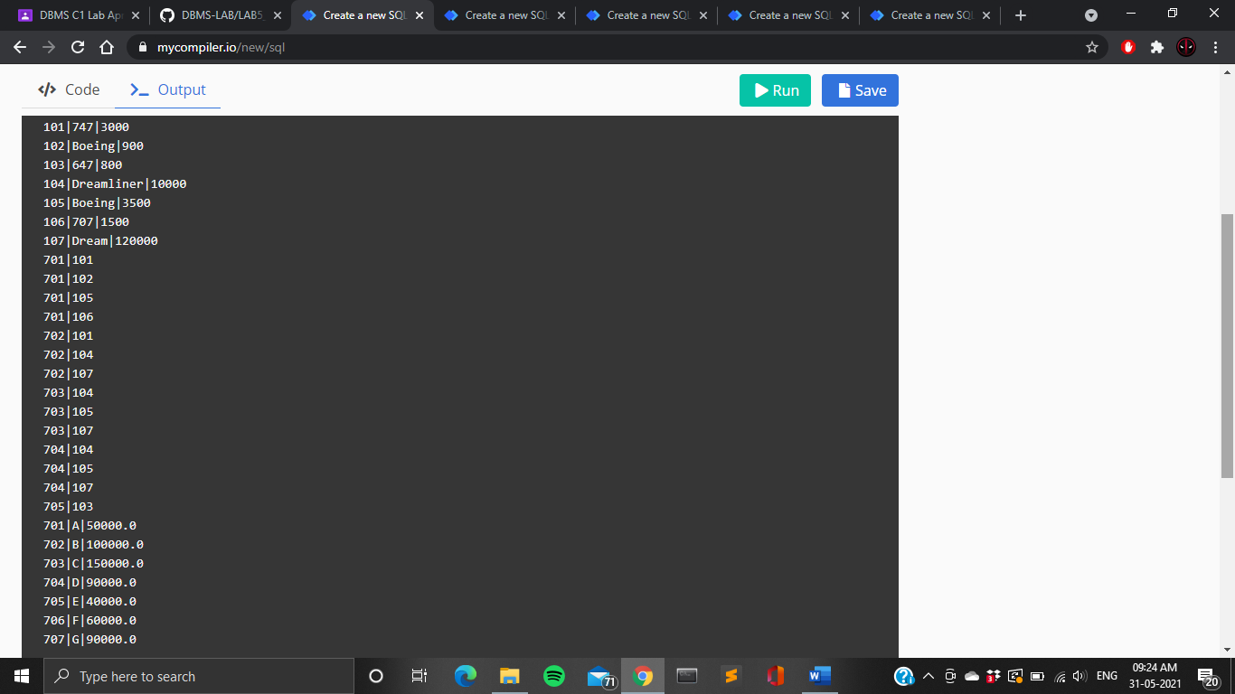





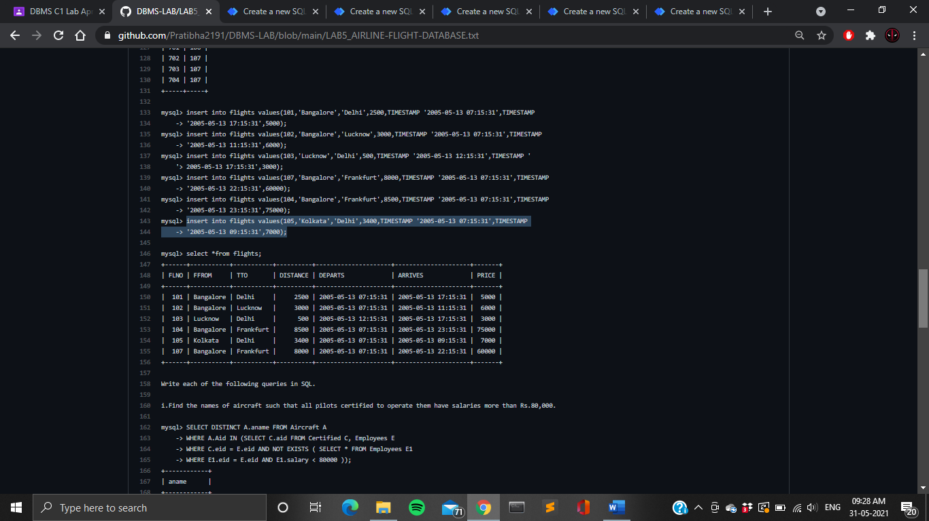

Note that the Employees relation describes pilots and other kinds of employees as well; Every pilot is certified for some aircraft, and only pilots are certified to fly.Write each of the following queries in SQL.

1. Find the names of aircraft such that all pilots certified to operate them have salaries more than Rs.80,000.

**SELECT DISTINCT A.aname FROM Aircraft A**

**WHERE A.Aid IN (SELECT C.aid FROM Certified C, Employees E**

**WHERE C.eid = E.eid AND NOT EXISTS ( SELECT * FROM Employees E1**

**WHERE E1.eid = E.eid AND E1.salary < 80000 ));**

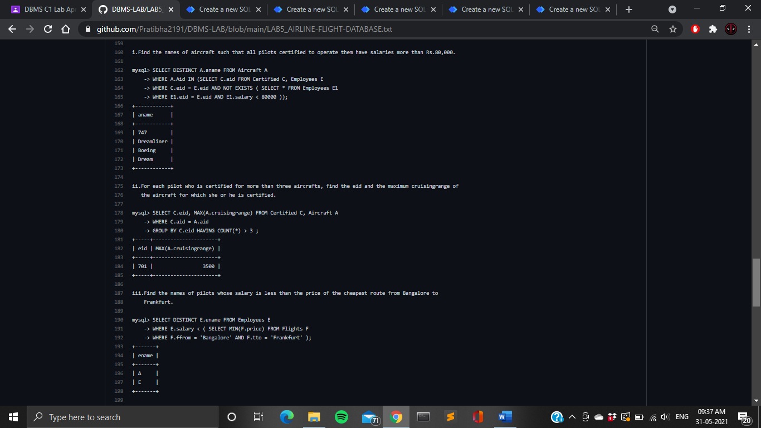

1. For each pilot who is certified for more than 3 aircrafts, find the eid and the maximum cruising range of the aircraft for which the person is certified.

**SELECT C.eid, MAX(A.cruisingrange) FROM Certified C, Aircraft A**

**WHERE C.aid = A.aid**

**GROUP BY C.eid HAVING COUNT(*) > 3 ;**



1. Find the names of pilots whose salary is less than the price of the cheapest route from Bengaluru to Frankfurt.

**SELECT DISTINCT E.ename FROM Employees E**

**WHERE E.salary < ( SELECT MIN(F.price) FROM Flights F**

**WHERE F.ffrom = 'Bangalore' AND F.tto = 'Frankfurt' );**



1. For all aircraft with cruisingrange over 1000 Kms, find the name of the aircraft and the average salary of all pilots certified for this aircraft.

**SELECT Temp.name, Temp.AvgSalary**

**FROM ( SELECT A.aid, A.aname AS name, AVG (E.salary) AS AvgSalary**

**FROM Aircraft A, Certified C, Employees E**

**WHERE A.aid = C.aid AND C.eid = E.eid AND A.cruisingrange > 1000**

**GROUP BY A.aid, A.aname ) AS Temp;**

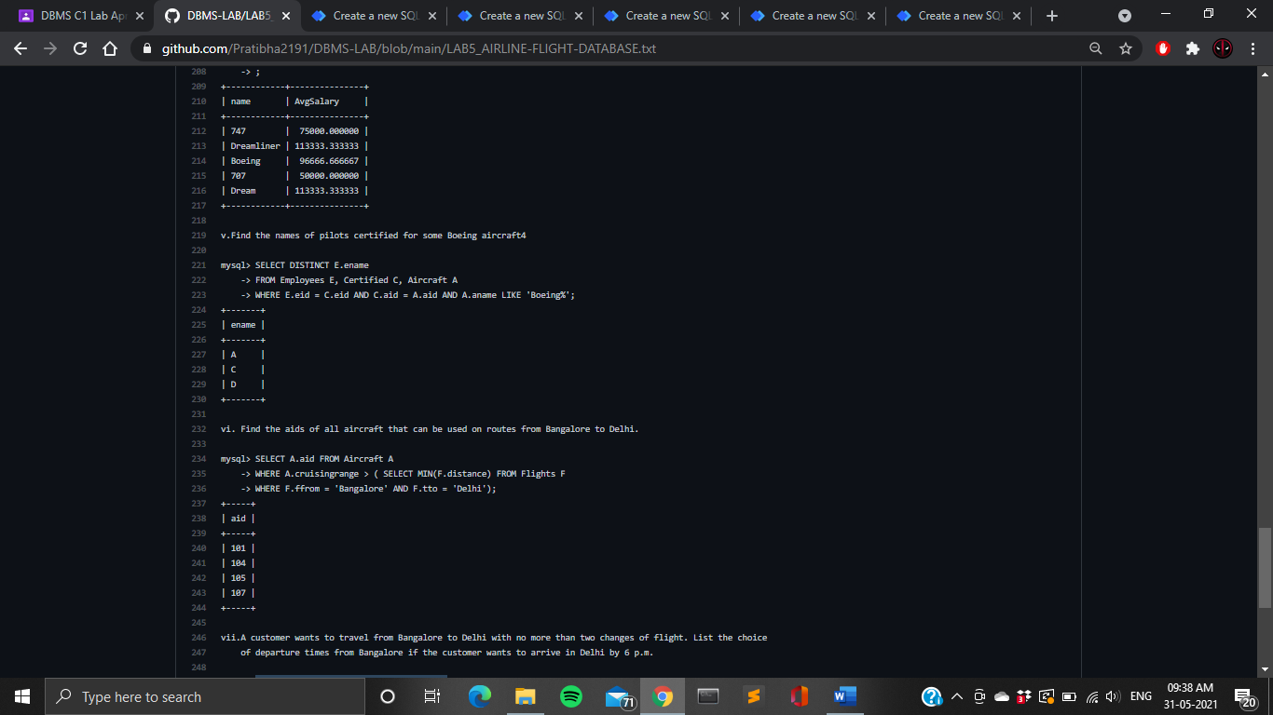

1. Find the names of pilots certified for some Boeing aircraft.

**SELECT DISTINCT E.ename**

**FROM Employees E, Certified C, Aircraft A**

**WHERE E.eid = C.eid AND C.aid = A.aid AND A.aname LIKE 'Boeing%';**



1. Find the aids of all aircraft that can be used on routes from Bengaluru to New  
   Delhi.

**SELECT A.aid FROM Aircraft A**

**WHERE A.cruisingrange > ( SELECT MIN(F.distance) FROM Flights F**

**WHERE F.ffrom = 'Bangalore' AND F.tto = 'Delhi');**



1. A customer wants to travel from Madison to New York with no more than two changes  
   of flight. List the choice of departure times from Madison if the customer  
   wants to arrive in New York by 6 p.m.

**SELECT F.departs,F.flno FROM Flights F**

**WHERE F.flno IN (( SELECT F0.flno FROM Flights F0**

**WHERE F0.ffrom = 'Bangalore' AND F0.tto = 'Delhi' AND extract(hour from F0.arrives) < 18)**

**UNION**

**(SELECT F0.flno FROM Flights F0, Flights F1**

**WHERE F0.ffrom = 'Bangalore' AND F0.tto <> 'Delhi'**

**AND F0.tto = F1.ffrom AND F1.tto = 'Delhi'**

**AND F1.departs > F0.arrives AND extract(hour from F1.arrives) < 18 )**

**UNION**

**(SELECT F0.flno FROM Flights F0, Flights F1, Flights F2**

**WHERE F0.ffrom = 'Bangalore' AND F0.tto = F1.ffrom**

**AND F1.tto = F2.ffrom AND F2.tto = 'Delhi'**

**AND F0.tto <> 'Delhi' AND F1.tto <> 'Delhi'**

**AND F1.departs > F0.arrives AND F2.departs > F1.arrives AND extract(hour from F2.arrives) < 18 ));**

